1. HASH FUNCTION – MD5

AIM
To implement the MD5 hash function and generate the hash value for a given message using Python.

ALGORITHM
- Start the program.
- Read the input text from the user.
- Convert the text into bytes.
- Apply the MD5 hashing algorithm.
- Generate the hash value.
- Display the hash value.
- Stop the program.

PYTHON CODE
import hashlib

text = input("Enter Text: ")

result = hashlib.md5(text.encode())

print("MD5 Hash Value:")
print(result.hexdigest())

SAMPLE OUTPUT

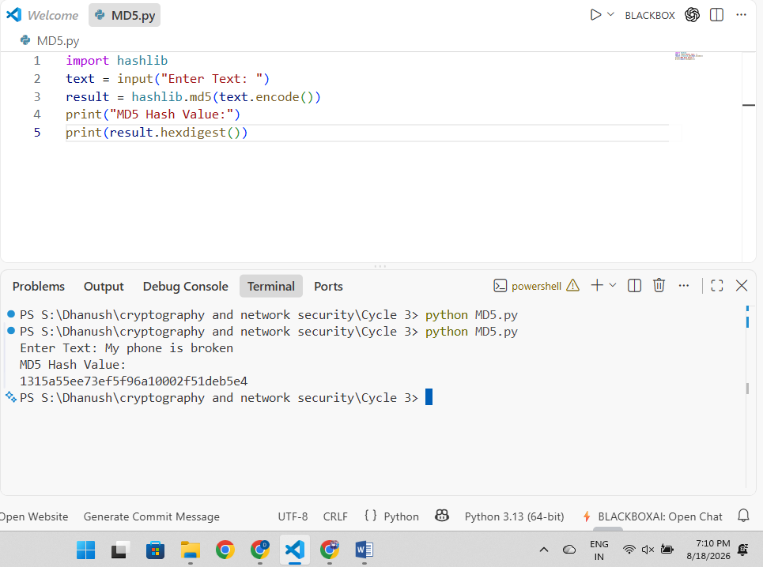

RESULT
Thus, the MD5 hash function was implemented successfully and the hash value was generated.

2. HASH FUNCTION – SHA512

AIM
To implement the SHA512 hash function and generate the hash value for a given message using Python.

ALGORITHM
- Start the program.
- Read the input text from the user.
- Convert the text into bytes.
- Apply the SHA512 hashing algorithm.
- Generate the hash value.
- Display the hash value.
- Stop the program.

PYTHON CODE
import hashlib

text = input("Enter Text: ")

result = hashlib.sha512(text.encode())

print("SHA512 Hash Value:")
print(result.hexdigest())

SAMPLE OUTPUT

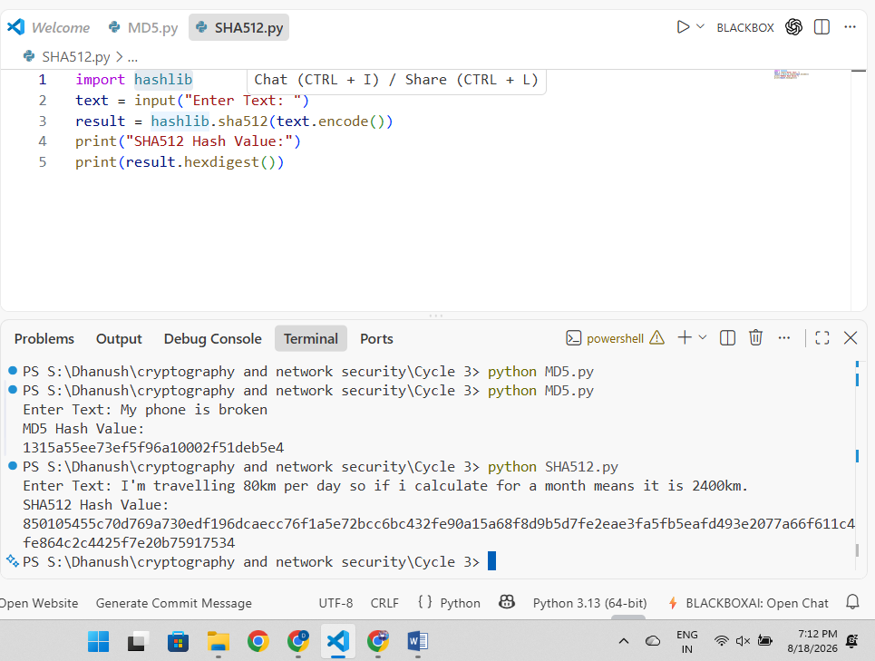

RESULT
Thus, the SHA512 hash function was implemented successfully and the hash value was generated.

3. HASH FUNCTION – SHA1

AIM
To implement the SHA1 hash function and generate the hash value for a given message using Python.

ALGORITHM
- Start the program.
- Read the input text from the user.
- Convert the text into bytes.
- Apply the SHA1 hashing algorithm.
- Generate the hash value.
- Display the hash value.
- Stop the program.

PYTHON CODE
import hashlib

text = input("Enter Text: ")

result = hashlib.sha1(text.encode())

print("SHA1 Hash Value:")
print(result.hexdigest())

SAMPLE OUTPUT

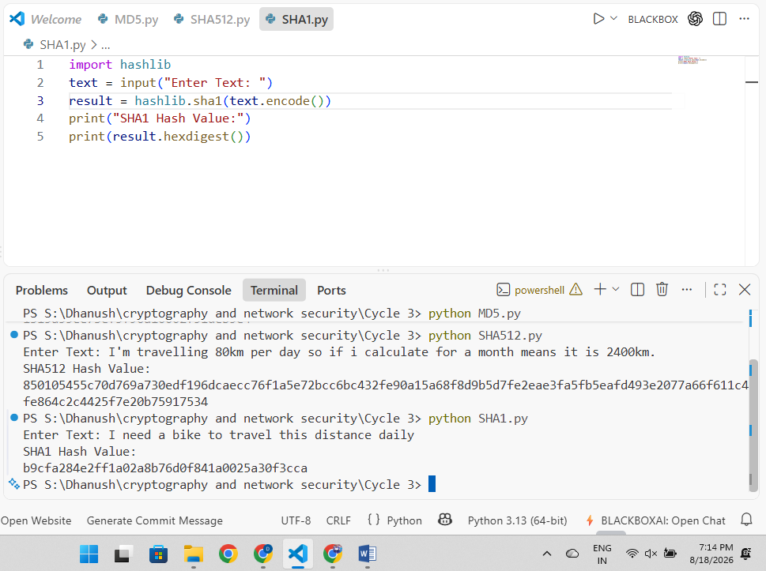

RESULT
Thus, the SHA1 hash function was implemented successfully and the hash value was generated.

4. DIGITAL SIGNATURE

AIM
To implement a Digital Signature algorithm for signing and verifying a message using Python.

ALGORITHM
- Start the program.
- Read the message from the user.
- Generate the hash value of the message.
- Create a digital signature using the private key.
- Verify the signature using the public key.
- Display the signature.
- Display the verification result.
- Stop the program.

PYTHON CODE
import hashlib

message = input("Enter Message: ")

n = 143
e = 7
d = 103

hash_value = int(hashlib.sha1(message.encode()).hexdigest(), 16)

signature = pow(hash_value, d, n)

print("Digital Signature:", signature)

verified_hash = pow(signature, e, n)

if verified_hash == (hash_value % n):
print("Signature Verified")
else:
print("Verification Failed")

SAMPLE OUTPUT

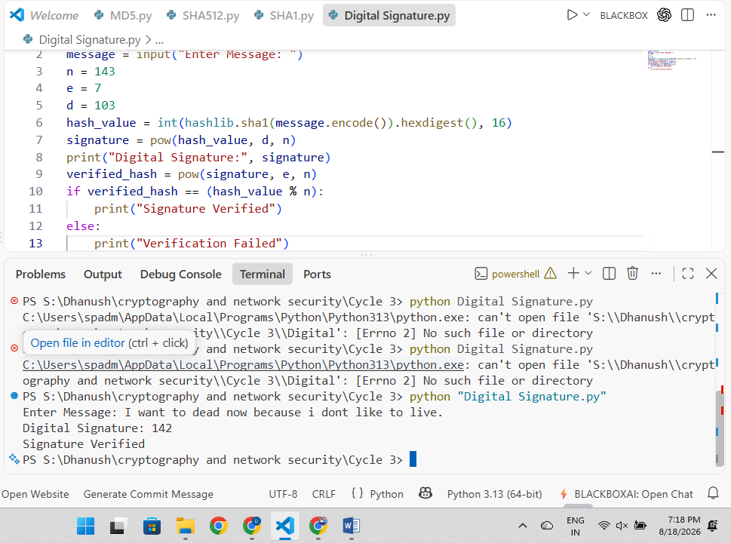

RESULT
Thus, the Digital Signature generation and verification process was implemented successfully using Python.

